**Project Planning Phase**

**Project Planning Template (Product Backlog, Sprint Planning, Stories, Story points)**

**Product Backlog, Sprint Schedule, and Estimation (4 Marks)**

|  |  |  |  |  |  |  |
| --- | --- | --- | --- | --- | --- | --- |
| **Sprint** | **Functional Requirement (Epic)** | **User Story Number** | **User Story / Task** | **Story Points** | **Priority** | **Team Members** |
| Sprint-1 | Analyse | USN-1 | As an admin, I will analyse the given dataset (Data pre- processing) | 20 | High | Suja S |
| Sprint-2 | Visualization | USN-2 | As a user, I can select the visualization type (Creating visualization) | 20 | Medium | Subalakshmi G |
| Sprint-3 | Dashboard | USN-3 | As a user, I can upload the datasets to the dashboard and view visualizations (Creating dashboard) | 20 | Medium | Subhiksha S |
| Sprint-4 | Predict | USN-4 | As an admin, I will predict the length of stay (Prediction) | 20 | High | Thaarani S |

**Project Tracker, Velocity & Burndown Chart: (4 Marks)**

|  |  |  |  |  |  |  |
| --- | --- | --- | --- | --- | --- | --- |
| **Sprint** | **Total Story Points** | **Duration** | **Sprint Start Date** | **Sprint End Date (Planned)** | **Story Points Completed (as on**  **Planned End Date)** | **Sprint Release Date (Actual)** |
| Sprint-1 | 20 | 6 Days | 24 Oct 2022 | 29 Oct 2022 | 20 | 29 Oct 2022 |
| Sprint-2 | 20 | 6 Days | 31 Oct 2022 | 05 Nov 2022 | 20 | 05 Nov 2022 |
| Sprint-3 | 20 | 6 Days | 07 Nov 2022 | 12 Nov 2022 | 20 | 12 Nov 2022 |
| Sprint-4 | 20 | 6 Days | 14 Nov 2022 | 19 Nov 2022 | 20 | 19 Nov 2022 |

**Velocity:**

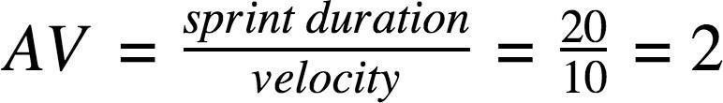

**Burndown Chart:**

A burn down chart is a graphical representation of work left to do versus time. It is often used in agile software development methodologies such as Scrum. However, burn down charts can be applied to any project containing measurable progress over time.

